ANNUAL REPORT FOR THE PERIOD 1st APRIL 2022 TO 31st MARCH 2023

Submitted to

GAUHATI UNIVERSITY, GUWAHATI
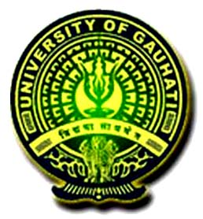

Submitted by
LANKA MAHAVIDIYALAYA, LANKA, HOJAI

Year of Establishment …1979

Address: Uttar Baluhander (Near NH 27) Lanka, Dist.- Hojai (Assam) 782445
Website: www.lanakmahavidyalaya.org.in
College E-mail ID: principal.lm@gmail.com
Name of the Principal: Dr. Phatik Tamuli
Phone (i) Office (with STD Code): 03674-255473 (ii) Mobile: 8812841012
Email ID of the Principal: tamuliphatik@gmail.com
Type of Management: State Govt.
Year of Provincialization: 25th December, 2005
Year of recognition of UGC Act, 1956 Under Section 2 F …Feb/1995……………………………Under Section 12B…Feb/1995…………………………….
Year of last NAAC accreditation: 2015 Grade / Points obtained: B

Programmes offered:
Programmes | Year of first affiliation | Year of permanent affiliation
B. A | 1984-85 | 23/2/1991
B.Sc
B. Com | 1990-91 | -
B.Voc.
BCA
M.A.
M.Sc
M.Com
Diploma
Certificate
Any other (please specify)

New Academic Programmes introduced during 2022-23: No
Student Enrolment during 2022-2023:
a) Under Graduate:
Programme | Semester | Intake capacity | Total admitted |  |  | SC |  |  | ST(P) |  |  | ST (H) |  |  | OBC/MOBC |  |  | PH
Programme | Semester | Intake capacity | M | F | T | M | F | T | M | F | T | M | F | T | M | F | T | M | F | T
B.A. | 1stSem/ 2ndSem | 650 | 301 | 334 | 635 | 76 | 84 | 160 | 10 | 15 | 25 | 09 | 15 | 24 | 92 | 98 | 190 | 0 | 0 | 0
B.A. | 3rdSem/ 4th Sem. | 650 | 211 | 328 | 539 | 42 | 55 | 97 | 09 | 19 | 28 | 14 | 17 | 31 | 57 | 97 | 154 | 0 | 0 | 0
B.A. | 5th Sem./ 6th Sem. | 650 | 185 | 289 | 474 | 31 | 42 | 73 | 10 | 21 | 31 | 17 | 14 | 31 | 58 | 71 | 129 | 0 | 0 | 0
B.A. | Total | 1950 | 697 | 951 | 1648 | 149 | 181 | 330 | 29 | 55 | 84 | 40 | 46 | 86 | 207 | 266 | 473 | 0 | 0 | 0
B.Sc. | 1stSem/ 2ndSem
B.Sc. | 3rdSem/ 4th Sem.
B.Sc. | 5th Sem./ 6th Sem.
B.Sc. | Total
B. Com | 1stSem/ 2ndSem | 120 | 76 | 16 | 92 | 06 | 03 | 09 | 03 | 02 | 05 | nil | nil | nil | 20 | 04 | 24 | 0 | 0 | 0
B. Com | 3rdSem/ 4th Sem. | 120 | 69 | 31 | 100 | 10 | 07 | 17 | 05 | 01 | 06 | 01 | 02 | 03 | 17 | 08 | 25 | 0 | 0 | 0
B. Com | 5th Sem./ 6th Sem. | 120 | 67 | 17 | 84 | 08 | 02 | 10 | 01 | 01 | 02 | 04 | 01 | 05 | 11 | 02 | 13 | 0 | 0 | 0
B. Com | Total | 360 | 212 | 64 | 276 | 24 | 12 | 36 | 09 | 04 | 13 | 05 | 03 | 08 | 48 | 14 | 62 | 0 | 0 | 0
B.Voc. | 1stSem/ 2ndSem
B.Voc. | 3rdSem/ 4th Sem.
B.Voc. | 5th Sem./ 6th Sem.
B.Voc. | Total
BCA | 1stSem/ 2ndSem
BCA | 3rdSem/ 4th Sem.
BCA | 5th Sem./ 6th Sem.
BCA | Total
Diploma
programme
Certificate programme
Other programmes
(Pl. Specify)
Grand Total |  | 2310 | 909 | 1015 | 1924 | 173 | 193 | 366 | 38 | 59 | 97 | 45 | 49 | 94 | 255 | 280 | 535 | 0 | 0 | 0

b) Post-Graduate (subject wise): N/A
Subject | Sem. | Intake  Capacity | Total Admitted |  |  | S.C. |  |  | S.T(P) |  |  | S.T.(H) |  |  | OBC/MOBC |  |  | P.H.
Subject | Sem. |  | M | F | T | M | F | T | M | F | T | M | F | T | M | F | T | M | F | T
 | 1stSem/ 2ndSem
 | 3rdSem/ 4thSem
 | Total
PGDCA | 1stSem/ 2ndSem

Final Examination Result (Regular Programmes only)

- Appeared
Examination | Total Appeared |  |  | SC |  |  | ST(P) |  |  | ST(H) |  |  | OBC/MOBC |  |  | PH
Examination | M | F | T | M | F | T | M | F | T | M | F | T | M | F | T | M | F | T
B.A. (General) | 146 | 173 | 320 | 17 | 22 | 39 | 11 | 14 | 25 | 10 | 11 | 21 | 35 | 40 | 75 | 0 | 0 | 0
B.Sc. (General)
B.Com.(General) | 17 | 05 | 22 | 03 | 01 | 04 | 0 | 0 | 0 | 01 | 0 | 01 | 05 | 01 | 06 | 0 | 0 | 0
PGDCA
BCA
B.Voc.
Other Courses

- Passed
Examination | Total Passed |  |  | SC |  |  | ST (P) |  |  | ST(H) |  |  | OBC/ MOBC |  |  | PH
Examination | M | F | T | M | F | T | M | F | T | M | F | T | M | F | T | M | F | T
B.A. (General) | 22 | 38 | 167 | 20 | 32 | 52 | 03 | 02 | 05 | 03 | 04 | 07 | 22 | 23 | 45 | 0 | 0 | 0
B.Sc. (General)
B.Com.(General) | 10 | 05 | 15 | 02 | 01 | 03 | 0 | 0 | 0 | 01 | 0 | 01 | 02 | 0 | 02 | 0 | 0 | 0
PGDCA
BCA
B.Voc.
Other Courses

Final Examination Result (Under graduate Major Course/ Honours Programme- Subject wise).
- Appeared
Major/ Honours subject | Total appeared |  |  | SC |  |  | ST (P) |  |  | ST(H) |  |  | OBC/ MOBC |  |  | PH
Major/ Honours subject | M | F | T | M | F | T | M | F | T | M | F | T | M | F | T | M | F | T
ECONOMICS (H) | 08 | 08 | 16 | 02 | 01 | 03 | 0 | 01 | 01 | 0 | 0 | 0 | 02 | 02 | 04 | 0 | 0 | 0
ENGLISH (H) | 18 | 21 | 39 | 02 | 02 | 04 | 01 | 0 | 01 | 0 | 01 | 02 | 03 | 04 | 07 | 0 | 0 | 0
POLITICAL SC. (H) | 21 | 16 | 37 | 04 | 02 | 06 | 01 | 01 | 02 | 0 | 02 | 02 | 05 | 03 | 08 | 0 | 0 | 0
HISTORY (H) | 10 | 16 | 24 | 02 | 01 | 03 | 0 | 01 | 01 | 02 | 0 | 02 | 03 | 03 | 06 | 0 | 0 | 0
HINDI (H) | 14 | 29 | 43 | 02 | 03 | 05 | 01 | 0 | 01 | 0 | 0 | 0 | 04 | 04 | 08 | 0 | 0 | 0
EDUCATION (H) | 10 | 17 | 27 | 03 | 03 | 06 | 00 | 01 | 01 | 02 | 01 | 03 | 04 | 05 | 09 | 0 | 0 | 0
ASSAMESE (H) | 11 | 35 | 46 | 02 | 02 | 04 | 0 | 01 | 01 | 01 | 02 | 03 | 03 | 04 | 07 | 0 | 0 | 0
BENGALI (H) | 03 | 20 | 23 | 01 | 02 | 03 | 0 | 0 | 0 | 0 | 0 | 0 | 02 | 03 | 05 | 0 | 0 | 0
B.COM (H) | 42 | 05 | 47 | 06 | 01 | 07 | 01 | 0 | 01 | 02 | 0 | 02 | 11 | 01 | 12 | 0 | 0 | 0
Grand Total | 95 | 162 | 255 | 18 | 16 | 34 | 03 | 05 | 08 | 05 | 06 | 12 | 26 | 28 | 54 | 0 | 0 | 0

- Passed
Major/ Honours subject | Total Passed |  |  | SC |  |  | ST(P) |  |  | ST(H) |  |  | OBC/ MOBC |  |  | PH
Major/ Honours subject | M | F | T | M | F | T | M | F | T | M | F | T | M | F | T | M | F | T
ECONOMICS (H) | 05 | 07 | 12 | 02 | 03 | 05 | 0 | 0 | 0 | 0 | 0 | 0 | 05 | 04 | 0 | 0 | 0 | 0
ENGLISH (H) | 14 | 21 | 35 | 02 | 02 | 04 | 0 | 0 | 0 | 01 | 01 | 02 | 04 | 05 | 0 | 0 | 0 | 0
POLITICAL SC. (H) | 23 | 11 | 34 | 02 | 03 | 05 | 0 | 0 | 0 | 0 | 0 | 0 | 04 | 06 | 0 | 0 | 0
HISTORY (H) | 07 | 12 | 18 | 01 | 04 | 05 | 0 | 0 | 0 | 0 | 01 | 01 | 04 | 03 | 0 | 0 | 0 | 0
HINDI (H) | 10 | 30 | 40 | 02 | 03 | 05 | 0 | 01 | 01 | 0 | 0 | 0 | 02 | 02 | 0 | 0 | 0 | 0
EDUCATION (H) | 07 | 18 | 25 | 02 | 03 | 05 | 0 | 0 | 0 | 01 | 0 | 01 | 03 | 03 | 0 | 0 | 0 | 0
ASSAMESE (H) | 08 | 31 | 39 | 02 | 05 | 07 | 01 | 0 | 01 | 0 | 01 | 01 | 03 | 04 | 0 | 0 | 0 | 0
BENGALI (H) | 04 | 20 | 24 | 01 | 03 | 04 | 0 | 0 | 0 | 0 | 0 | 0 | 03 | 02 | 0 | 0 | 0 | 0
B.COM (H) | 37 | 05 | 42 | 07 | 01 | 05 | 01 | 0 | 01 | 02 | 00 | 02 | 09 | 01 | 10 | 0 | 0 | 0
Grand Total | 155 | 155 | 269 | 21 | 27 | 45 | 02 | 01 | 03 | 04 | 3 | 7 | 37 | 30 | 10 | 0 | 0 | 0

Final Examination Result (Post Graduate Programmes- Subject wise): N/A
a) Appeared

Subject | Total appeared |  |  | SC |  |  | ST (P) |  |  | ST(H) |  |  | OBC/ MOBC |  |  | PH
Subject | M | F | T | M | F | T | M | F | T | M | F | T | M | F | T | M | F | T
Grand Total

b) Passed
Subject | Total Passed |  |  | SC |  |  | ST (P) |  |  | ST(H) |  |  | OBC/ MOBC |  |  | PH
Subject | M | F | T | M | F | T | M | F | T | M | F | T | M | F | T | M | F | T
Grand Total

Library facility as on 31-03-2023

No. of Books | No. of Periodicals | No. of Manuscripts | No. of Journals | No. of E-journals | No. of library users during 2022-23
18,436 | Nil | Nil | Nil | Nil | 5369

Detail of Teaching Staff as on 31-03-2023

Number of |  | Total | Number of teachers with
Assistant Professors | Associate Professors | Total | Ph.D. | MPhil | NET | SLET | D.Lit. | D.Sc.
23 | 12 | 35 | 11 | 08 | 10 | 08 | NIL | NIL

Computer and Internet facilities:
a) Total number of Computers: 82 b) Number of computers with INFLIBNET- NLIST access: No
c) Number of ICT enabled class room(s) / smart class room (s): 06

Extra-curricular and Co-curricular activities:
a) No. of N.C.C. Cadets: Nil b) No. of N.S.S. Volunteers: 70
c) No. of Scouts & Guides /Rovers /Rangers: Nil
d) Achievements/Awards of students in Regional/National events: None

Faculty Development Programmes organized by the college during 2022-23:
Seminars/Workshop/Webinars conducted (2022-23):
1. RUSA 2.1 Training Program on NAAC Preparedness & NEP-2020; implementation in the Colleges of Assam on 21st February, 2023
2. Extension- awareness program on marketing of the products of self-help group on 1st January, 2023
3. Invited talk on " role of radio broadcasting in the development of Assamese lyrics & literature, organised by Department of Assamese & IQAC on 5th April, 2023.
4. Two days district level training program on “life skill leadership development, child protection and cyber safety", organised by incubation centre for mental health & growth, IQAC and Samagra Siksha, govt. of assam on 21st to 22nd march.
5. Two days district level training program on " emotion wellbeing & mental health" organised by Incubation Centre for mental Health & Growth, IQAC and SAMAGRA SIKHSA, Govt. of Assam on 14th and 15th March.
6. Webinar on IPR and its Relevance to Higher Education on 25th August, 2023.

Research Projects (2022-23):
a. Completed:
b. Ongoing:

Academic Activities:
a) Publication of research papers in peer reviewed/UGC care list journals during 2022-23.
1. Lukendra Kakati, 2022: Mathematical Modelling of Blood Flow through an Inclined Circular Stenosed artery with an Annular axially symmetric Clot layer. Neuro Qantology, (ISSN 1303-5150).
2. Lukendra Kakati, 2022: MHD and Radiation Effects on an Oscillatory Free Convective Flow Past a Vertical Plate in Slip-Flow Regime with Variable Suction and Periodic Plate Temperature. Aadvances and Applications in Mathematical Sciences, (ISSN 0974-6803).
3. Lukendra Kakati, 2022: Thermal Diffusion and Thermal Radiation effects on a MHD oscillatory free convective flow past a vertical plate in slip-flow regime with variable suction and periodic plate temperature, International Journal of Mechanical Engineering, (ISSN 0974-6803).
4. Lukendra Kakati, 2022: Effect of Velocity Slip on MHD Viscoelastic Fluid Flow Past a Porous Stretching Sheet with Variable Viscosity: Application to Hemodynamic. NEUROQUANTOLOGY, (ISSN 1303-5150).
5. Lukendra Kakati, 2022: Consonant Phoneme of Koch Language: An Analytical Study. International Journal of Mechanical Engineering, (ISSN 0974-5823).
6. Indramohan Hazarika, 2022: Consonant Phoneme of Koch Language: An Analytical Study. International Journal of Mechanical Engineering, (ISSN 0974-5823).
7. Anil Kumar Saikia, 2022: Impact of Microfinance on Agriculture Sector: An Analysis. International Journal of Early Childhood Special Education, 2022 ISSN: 1308-5581 Vol. 14, Issue 3.
8. Mukul Barthakur, 2022: Wansuwa Misewa: A Socio Religious Festival of the Tiwa Community of Assam. UTKAL HISTORICAL RESEARCH JOURNAL& Department of History &ISSN: 0976-03132. ISSN 0976-03132
XXXV,No 4(i)
9. Mukul Barthakur, 2022: Traditional Birth Beliefs and Practices of the Tiwa Community of Assam: A philosophical Outlook. Naagfani, ISSN-2321, Vol-43, Issue -III.
10. Mukul Barthakur, 2022: SAGRA KHAM: A religious and Social Festival of the Tiwa Community of Assam. ANVESAK, ISSN-03784568, Vol. No. 52, No-11(II).
11. Mukul Barthakur, 2022: Death Disposal of Tiwa Community: A Philosophical Outlook. DOGO-RANGSAN Research Journal, ISSN: 2347-7180 VOL.:X, ISSUE-XIX.

b) Publication of Chapter(s) in Books during 2022-23 (Only those considered for API Score).
1. Rupmala Hojai, 2022: SAHITYA SAMANVAY: A Ethical Teaching of Jaina Philosophy, an overview. Hojai Dimahasao Karbi Anglong Zone, Assam College Teacher Association, ISBN ISBN- 978-8-195-08206-4
2. Mousumi Nath, 2022: SAHITYA SAMANVAY: MUKTIJUDHAR PREKHAPOTE SELINA HUSSAINER NIRBACHITA UPANASH. Hojai Dimahasao Karbi Anglong Zone, Assam College Teacher Association, ISBN ISBN- 978-8-195-08206-4.
3. Kamaleswar Kalita, 2022: Sikan Sailee aru siksharthir agrha. Panchajanya Book,
4. Raju Saikia, 2022: A cross district analysis of Human development determinants in Assam. Hojai-Dima Hasao-KKarbianglong Zone, ACTA Women cell, ISBN 978-8-195-08206-4.
5. Lukendra Kakati, 2022: Magnetic Confinement Tokomak collider (MCTC) Hub induced instabilities Using fuzzy Defferential inclusion. P.K. Publishers & Distributors, New-Delhi, ISBN 987-93-92239-32-8.
6. Ankur Hazarika, 2022: A Queer reading of hostel room 131. Hojai-Dima Hasao-Karbianglong Zone, ACTA Women cell, ISBN 978-81-950561-6-3.
7. Jatan Saha, 2022: Satinath Bhadhurir ‘Chitrogupter file’Ebong Birendra Kumar Bhattacharjer ‘Protipod’ uponnase shromojibi manuser sangram:Ekti tulonamulok alochana. Department of Bengali, Assam University, ISSN: 2320-0715.
8. Silpisikha Baruah,2022: URANI ASOMOR JATI PRATHA. Natun Padatik, ISBN 2250-3471.

9. Anuradha Chaudhuri, 2022: Sahitya Samanvay : A Deconstructive Female- Reading of Assamese Stories. Hojai Dima-Hasao Karbi Anglong Zone, ACTA, ISBN 978-8-195-08206-4
10. Iftikhar Hussain, 2022: SAHITYA SAMANVAY: The Hour Before Dawn. Hojai Dima-Hasao Karbi Anglong Zone, ACTA, ISBN- 978-8-195-08206-4
11. Nibedita Nath, 2022: SAHITYA SAMANVAY: PHANISHARNATH RENU KI KAHANIU MEA SAMAJ BEBASTA. Hojai Dima-Hasao Karbi Anglong Zone, ACTA, ISBN- 978-8-195-08206-4
12. Sabnam Hazarika, 2022: AHITYA SAMANVAY: JYOTI PRASHAD AGARWALAR GEETAR ATI BISHLESHAN. Hojai Dima-Hasao Karbi Anglong Zone, ACTA, ISBN- 978-8-19508206-4

c) Publication of Books during 2022-23 (only those considered for API Score).

d) Details of Books and Journals published by the College during 2022-23:

e) Details of papers presented by the teachers during 2022-23:

e) Refresher Course/Orientation Course/Short Term Course/Faculty Development Programme /Faculty Induction Programme attended by the teachers during the 2022-23:
1. Dr. Porishmita Buragohain, Orientation on faculty development programme organized by Teaching learning Centre, Ramanujan college, University of Delhi, 20th January to 19th Feb, 2022.
2. Bini Borgohain, Induction training programme organized by Department of higher education, Government of Assam, 25th June to 26th June, 2023.
3. Bijoy Kumar Dey, Induction training programme organized by Department of higher education, Government of Assam, 25th June to 26th June, 2023.
4. Darshna Kalita, Induction training programme organized by Department of higher education, Government of Assam, 25th June to 26th June, 2023.
5. Ananya Ghosh, Induction training programme organized by Department of higher education, Government of Assam, 25th June to 26th June, 2023.
6. Sangita Nandi, Induction training programme organized by Department of higher education, Government of Assam, 25th June to 26th June, 2023.
7. Dr. Nibedita Nath, Orientation on faculty development programme organized by Teaching learning Centre, Ramanujan college, University of Delhi, 20th January to 19th Feb, 2022.
8. Dr. Nibedita Nath, two weeks Faculty development programme organized by Teaching learning Centre, Ramanujan college, University of Delhi, 5th to 19th November, 2022.

Awards/Fellowship received by the teachers (2022-23): Nil

Patents (2022-23): Nil
Teachers Visited abroad during 2022-2023: 01

Hostel facilities: No. of Boys Hostel: N/A Total Seats: N/A
No. of Girls Hostel: 01 Total seats: 30

Sports facilities: | Lanka Mahavidyalaya has one indoor stadium having the facilities of badminton, volleyball, and tennis courts.
Auditorium/ Seminar/Conference Room: | Lanka Mahavidyalaya has one seminar hall having the seat capacity of 100.
Specialized laboratory/ studio/ facility: | 01
Augmentation of infrastructural facilities during the period 2022-2023: | Nil
Technology up gradation during the period 2022-22023: | For the technological support the college has upgraded the internet facility with the Bandwidth range-20 MBPS under the Railway Broadband connectivity. Moreover the college has installed three Projectors for the improvement of digital class and Purchased 7 numbers of Computer sets for Digital Laboratory and for some Departments.
Financial aid to students during the period 2022-2023: | During this session the 71 students availed the Government scholarships, which included ISHAN UDAY SPECIAL SCHOLARSHIPS FOR NER, POST MATRIC SCHOLARSHIP FOR SC/OBC STUDENTS OF ASSAM.  Moreover, 1380 students have availed the Freeship’s provided by the Government of Assam, during the session 2022-23.
Activities of the student counseling and Guidance Cell during the period (in brief) | The College, under the leadership of Career & Counseling Cell of IQAC, organized various awareness program, seminar, workshop etc. during the session 2022-23.  Specially, the college becomes successful to make placements of 47 students, out of 50, who have attended the “Training Cum Placement on Retail Sales Associates” organized by the Career Guidance and Counseling Cell, IQAC in collaboration with ASDM.
Placement of students (in brief): | During the Session 2022-23, almost 100 students have placed in various Government and Private Sector Institution.
Activities of Alumni Association during 2022-2023: | Lanka Mahavidyalaya,Lanka is established in 1979, a number of alumni got education from this reputed institution. Though this institution is located in rural area, it has a great contribution in the educational development of the rural students. Many alumni of this college are well-known in their respective fields i.e. Politics, Education, Judiciary, Literature, Sports, Agriculture, Business and Industry, Social Work and Public Speaking. The college provides an opportunity to the alumni to interact and share their experience with students during the College Week in every year.  - Although, the College has not a registered Alumni Cell, our Alumni Association works for the overall development of students as well as the institution. It helps our institution not just financially, but in terms of academic planning, placements of students, career guidance and technological guidance.  - Our Alumni Association organizes: Guest lectures on various subjects and provide guidance from the experts of various fields to the students.  - Some of our alumni are industrialists; they share their knowledge and expertise with the students.  - Alumni Association helps to organize educational and industrial visits for the students.  - Alumni Association provides information about the job opportunities available in their fields. Alumni Association organizes various Games and Sports Competitions in the College Campus.  Financial Support  On the initiatives of LMAA, two individuals viz. Mrs. Kankana Tamuli and Mr. Hemanta Goswami and contributed Rs. 10000/- (ten thousand) and 5000/- respectively in cash during 2023-24.
Community Outreach Programme during 2022-2023: | Lanka Mahavidyalaya in collaboration with IQAC had organized during the period 2022-23 Community Outreach Programmes such as Extension Awareness Programme on Marketing of the Products of Self-help Group on 1st April 2023, Workshop on Willpower as Key Success on 20th March, Two-day District Level Training Programme on “Life Skill Leadership Development”, “Child Protection and Cyber Safety” on 21st March- 22nd March and Two-day District Level Training Programme on “Emotion, Well-being and Mental Health” on 14th March-15th March, 2023.
Any other relevant information:

NB: Please provide three best high-resolution photographs of any activity/event/infrastructural facility of the college during the year 2022-23.

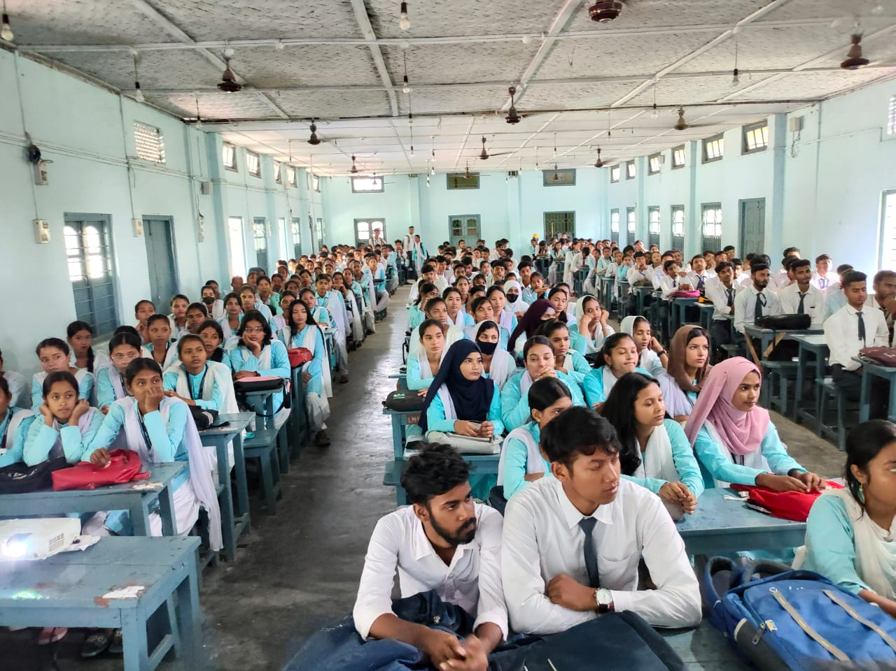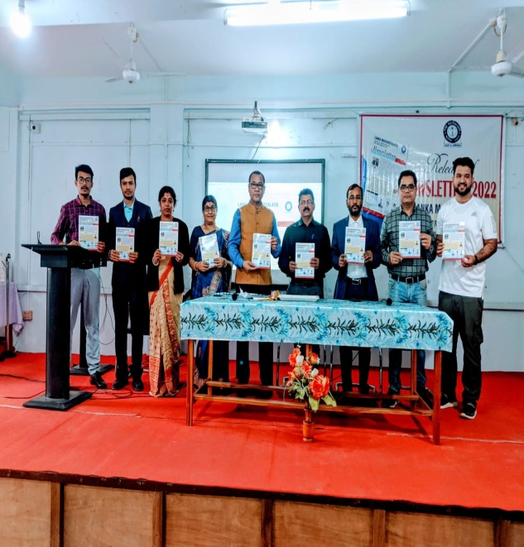

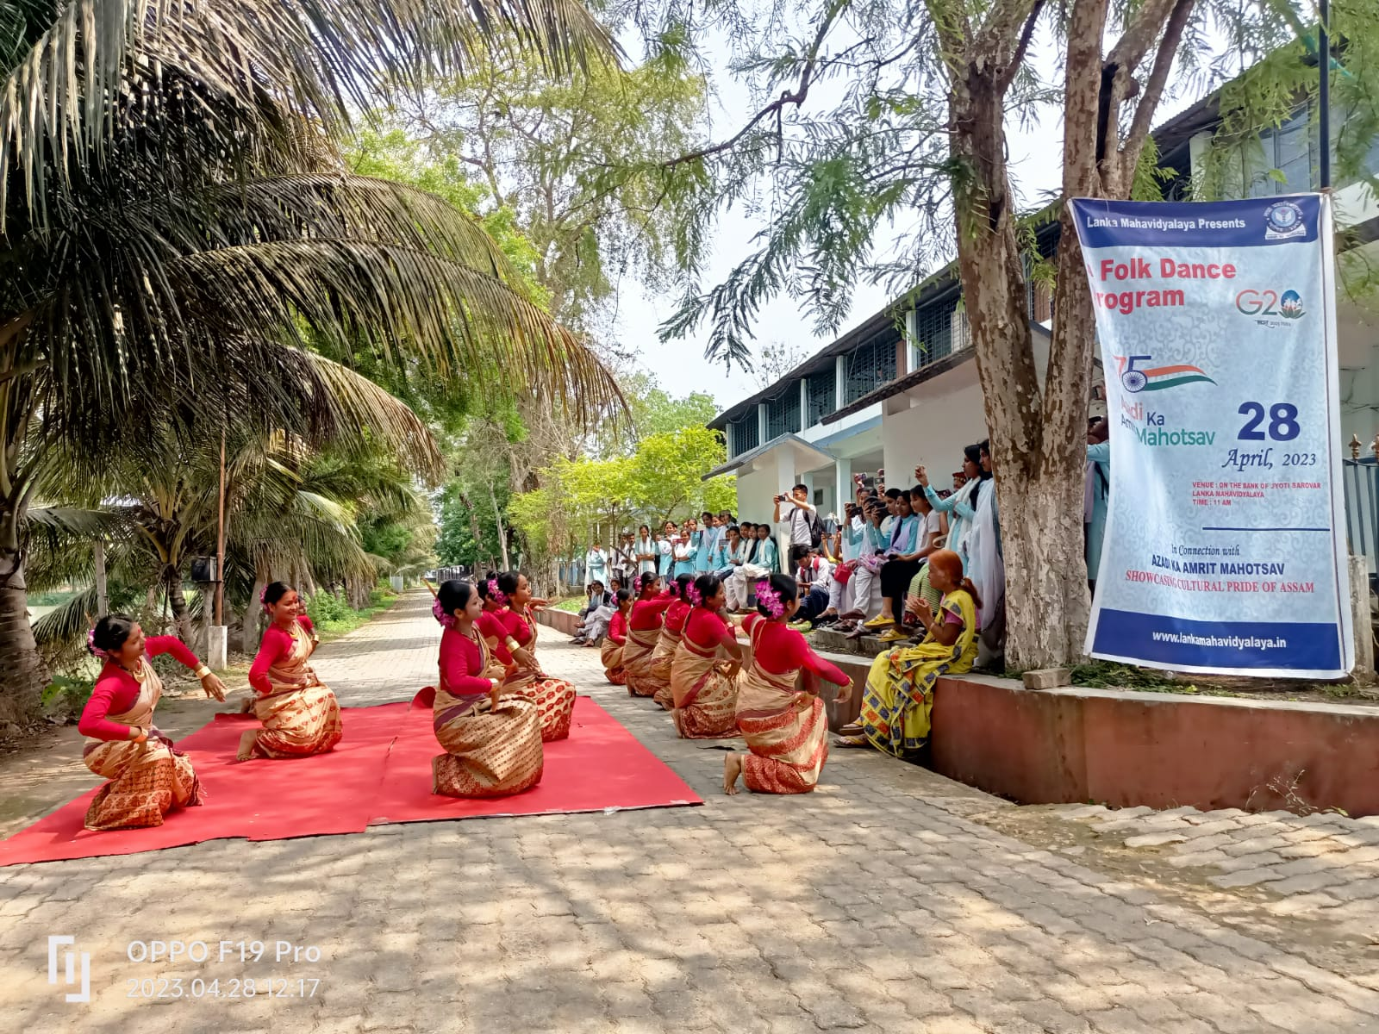

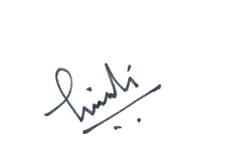
Principal

Lanka Mahavidyalaya
Lanka:Hojai:Assam

